

CANVASES & EXAMPLES
Communication guide

In the next pages, you’ll find an array of work canvases that will help you build and write your press releases, texts and announcements before posting and publishing in your community. And don’t forget to share your communications and successes with us!

Table of contents

Press Release 3
Press Release for Crisis Management 6
News Announcement 8
Patnership Announcement 11
Season Launch 14
Start of a Tournament 17
Registration period 20
Generic Announcement 22
Nomination 24
President’s Message 26
Facebook Post 28
Twitter Post Erreur ! Signet non défini.
Instagram Post 36
Snapchat Post Erreur ! Signet non défini.

Note: To use the canvases below, please refer to the Word document.

Note: The masculine gender is used as a neutral gender with the sole intent of simplifying the text.


YOUR LOGO

[Title: Press Release]

(City, Province), Date – [Name of the organization, MHA] + [press release subject].

“[Quote by the person in charge of the organization, region or MHA]”, acknowledges [Name of the person + title of that person].

[Additional and meaningful explications to the press release]

- 30 -

Source:
[Name of the person in charge]
[Title/function]
[Name of the organization, region, MHA]
[Contact information - email and/or phone]




A first edition for the Development Day for Coaches in Québec

This great novelty will take place under the theme “Becoming better for our players.”

(Montreal, Qc), Tuesday, August 14, 2018 – Hockey Québec, in collaboration with the Ligue de hockey midget AAA du Québec (LHMAAAQ), is proud to announce the first ever Development Day for Coaches in Québec under the theme Becoming better for our players. The event of unparalleled magnitude will be held on Monday, October 8, 2018, it is governed by each of the fifteen teams of the LHMAAAQ, who are at the head of our men’s integrated structures.

“We’re very happy to be able to count on the support of the LHMAAAQ for the Development Day. Offered to all the coaches, this seminar is part of the directions we aim in our strategic plan, which is to offer at least one annual provincial continuing education opportunity for coaches of all levels. By bringing all these people together on a single day, we also ensure that everyone gets a consistent message and encourages constructive conversations between the various stakeholders. All of our players will benefit,” said Paul Ménard, Hockey Québec’s general manager.

“The Ligue de hockey midget AAA du Québec is very proud to offer, in collaboration with Hockey Québec, this seminar to the entire province. This event will highlight the skills of the coaches of the League, as well as promote a sharing of knowledge from the top of the development pyramid of Quebec minor hockey,” says the director general of LHMAAAQ, Georges Marien.

Every coach in the province, whether from women’s or men’s hockey, whether in elite, competitive, recreational or school sector, will be invited to participate in this free development day organized by the midget AAA team within its territory.

“This development day perfectly fits with the continuing education required by the National Coaching Certification Program (NCCP)”, says the technical director of the federation, Yves Archambault.

Two development components
- Speciality Clinic – Puck Control
A clinic done in two steps, theory (in class) and practical (on the ice), it will be centred on the development of individual skills with the puck.

- Small area games
This training, offered in class, will be supported by videos coming from a league comity. The master coaches will explain the importance of playing well in small areas, as well as share the best drills they use with their LHMAAAQ team, both offensively and defensively.

Hockey Québec and the Ligue de hockey midget AAA du Québec invite all the coaches throughout the province to take part in this first ever provincial Development Day. It’s a great, unique, accessible and free way to share and acquire new knowledge with the main objective to improve for our players!

- 30 -

Source
Marie-Joël Desaulniers
Communications and regional support coordinator
Hockey Québec
mjdesaulniers@hockey.qc.ca
B: 514 252-3079, # 3550

YOUR LOGO

[Title: Press Release for crisis management]

(City, Province), date – [Name of the organization, MHA] + [press release].

“[Quote by the person in charge of the organization, region or MHA]”, acknowledges [Name of the person + title of that person].

[Additional and meaningful explications to the press release]

- 30 -

Source:
[Name of the person in charge]
[Title/Function]
[Name of the organization, region, MHA]
[Contact information - email and/or phone]

Hockey Québec will make the officials’ training mandatory for bantam players

(Montreal, Qc), Thursday, October 11, 2018 – In the wake of the events that took place during a bantam match between the Reds and the Greens last weekend, Hockey Québec will make a condensed version of the officials’ training mandatory to bantam players who are starting their first year.

“A situation like this one is unacceptable. We don’t want any more of these in our arenas. By forming all our bantam players, we firmly believe that it will help them understand what is officiating and its profession, and it should prevent situations like this in the future,” says the General Director of the Federation, Paul Ménard.

This training will be offered at no cost to all our bantam players. It should begin in the coming weeks for the present players and will be completed by the holidays. Starting next season (2019-2020), the training will be given before the beginning of the regular calendar.

Hockey Québec will make no further comments on this issue.

- 30 -

Source
Marie-Joël Desaulniers
Communications and regional support coordinator
Hockey Québec
mjdesaulniers@hockey.qc.ca
B: 514 252-3079 # 3550

**** This press release is purely fictional and was written for the sole purpose of this guide. It doesn’t refer to any situation that happened in the past or in the present.

[Title: News announcement]
YOUR LOGO

(City, province), date – [Name of the organization, region, MHA] + [subject of the announcement].

“[Quote by the person in charge of the organization, region or MHA]”, acknowledges [Name of the person + title of that person].
[Additional and meaningful information to the announcement]

[Name of the organization, region, MHA] wishes [subject of the announcement].

- 30 -

For further information about this announcement, please contact:
[Name of the person in charge]
[Title/Function]
[Name of the organization, region, MHA]
[Contact information - email and/or phone]


Playing half-ice for our novice players: “The most natural thing in the world”

(Montreal, Qc) – Monday, October 1, 2018 - Playing in small areas will be implemented to all novice teams starting next season (2019-2020) across Canada. Hockey Québec wanted to talk with players’ parents who are already taking place in one of the pilot projects installed this season. Discussions on the benefits that playing in small areas will bring to the development of the players.

MAHG1 and MAHG 2 coach, Mathieu Hamelin considers this change to be completely natural for the development of our young players.

“It’s the most natural thing in the world that our children play in an environment that is proportional to their size. Just look at what is already done in other sports, for example in basketball, it is not asked that a 6- or 7-year-old throw the ball in a basket that is three metres high. Same thing in soccer; the players don’t cover a 120-metre distance during games,” says the coach who also coaches soccer during summer.

His comparison even continues with school. “In elementary school, chairs and desks are adapted to the size of the children. It is proven that a better posture will greatly improve students’ listening and attention in the classroom,” adds the one who hopes that this change will also ensure better learning on the ice.

As for Francis Lahaie, who coached the Jaguars in the minor hockey association of Roussillon, during the pilot project last season, the game in small area “contributes to the individual development of each player. With a smaller surface, young players develop more team play and are subject to making more decisions, and more quickly. Their learning of the collective game is improved. “

Touch the puck twice as much
The player’s opportunities to be engaged in the play are doubled when the playing area is smaller. All players are closer to the game and have much more opportunity to touch the puck.

“All the players are closer to the puck. They take possession more often and are therefore more engaged in the game. Their interest in the game will also increase. They also develop their individual skills and are invited to make more decisions quickly, such as a pass for example, “said David Gosselin, dad of a young player who participated in the pilot project in Pointe-Lévy, during the 2017-2018 season.

“I really believe that playing in small areas is good. Not only to produce better players, but, above that, to better retain our players. It will allow players to increase their implication in the game. This is a significant impact as it is our national sport,” says Hamelin.

Learn the rules: in time.
Certain parents argue that playing half-ice will delay the learning of hockey game system rules. A theory that Mr. Gosselin denied from the outset.

“Your child only has to watch hockey on TV or play video games, for example, and he will be introduced to the rules. And if that’s not the case, he’ll have plenty of time to learn them early in his atom season. It is much more important, in my opinion, to focus on the teaching of early skills than on regulations. That is what will have an impact on his development,” he concludes.

Hockey Québec wishes to thank Francis Lahaie, Mathieu Hamelin and David Gosselin for their collaboration and wished all the players an excellent 2018-2019 season.

- 30 -

Source
Marie-Joël Desaulniers
Communications and regional support coordinator
Hockey Québec
mjdesaulniers@hockey.qc.ca

[Title: Partnership announcement]
PARTNER’S LOGO
RE LOGO
YOUR LOGO

(City, province), date – [Name of the organization, region, MHA] + [subject of the announcement].

“[Quote from your partner, its representative]”, says [Name of the person + his title].

“[Quote by the person in charge of the organization, region or MHA]”, acknowledges [Name of the person + title of that person].

[Additional and meaningful information to the announcement]

[Name of the organization, region, MHA] wished to thank [name of the partner] for his implication and devotion towards our players.

- 30 -

For further information about this announcement, please contact:
[Name of the person in charge]
[Title/Function]
[Name of the organization, region, MHA]
[Contact information - email and/or phone]

[Name of the person in charge]
[Title/Function]
[Name of the organization, region, MHA]
[Contact information - email and/or phone]


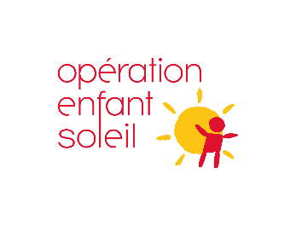
Hockey Québec, in collaboration with Opération Enfant Soleil, produces 23 video capsules specifically for para hockey

(Montreal, Qc), Thursday, November 30, 2017 – Hockey Québec, in collaboration with Opération Enfant Soleil, has produced 23 technical skills video capsules specifically for para hockey. Created to teach coaches and para hockey players, the design and work of these capsules were done in collaboration with the biomechanist of Laval University and former elite player Léandre Gagné-Lemieux.

“I decided to participate in the capsule project in order to bring a scientific aspect to the practice of para hockey (sledge hockey). Science is not really used in hockey in general, and athletes, like coaches, would benefit greatly from better knowledge of these elements,” says the biomechanicist.

“Léandre’s participation allowed us to add a theoretical notion as well as translate the technical gestures shown in the different capsules. These will offer a lot of educational material for all our coaches and players who want to improve their game, “adds the coordinator of the para hockey program at Hockey Québec, Mariève Blais.

Léandre Gagné-Lemieux mainly ensured that the moves were described correctly, both in terms of the correct use of the descriptive terms and in the identification of the correct parameters of the movement.

“As a sports biomechanist, I see the movement primarily in relation to the external forces that act to create it. With such an approach, we can identify elements of the movement that are sometimes invisible or barely visible,” says one who is a lecturer in medicine in the Department of Kinesiology at Laval University.

The 23 capsules can be viewed the Hockey Québec website, under the Programs tab, Para hockey.

Fonds Josée Lavigueur from Opération Enfant Soleil
The capsules were made possible thanks to the Fonds Josée Lavigueur of Opération Enfant Soleil. These funds, which aim to prevent illness among young people through physical activity, also aim to provide access to sports activities, particularly for children with disabilities and children aged 5 and under, as well as the prevention of overweight and obesity in the 18 and under age group.

Hockey Québec warmly thanks everyone involved in the production of these capsules. Starting with the Josée Lavigueur Fund of Opération Enfant Soleil for their involvement and support in this project; the biomechanist Léandre Gagné-Lemieux ; Jean Labonté, who acted as a technical consultant, being a former player and captain of the National Sledge Hockey Team; Not to mention all the volunteer players who lent themselves to the game during filming last winter (Aurélien Bucquet, Sophie Forest, Francis Lacombe, Antoine Vachon-Lehoux, Vincent Lemay, Joey Leroux, Vanessa Racine, Benoit St-Amand, Raphaëlle Tousignant, Étienne Tremblay and Alain Tremblay - pusher).

- 30 -

Source
Marie-Joël Desaulniers
Communications and regional support coordinator
Hockey Québec
mjdesaulniers@hockey.qc.ca

Season Launch [Years] + [Name of the Team] [Title: Season launch]
YOUR LOGO

(City, Province), Date – [Name of the organization, region, MHA] + [meaningful information about the launch of the season – festivities, events, Xth season, etc.].

« [Quote by the person in charge of the organization, region or MHA]”, acknowledges [Name of the person + title of that person].

[Additional and meaningful information to the announcement]

[Name of the region, MHA, organization, league] wishes an excellent [XXXX] season to all our players.

- 30 -

Source:
[Name of the person in charge]
[Title/Function]
[Name of the organization, region, MHA]
[Contact information - email and/or phone]


2018-2019 Season Launch

A Showcase to launch the first season of the feminine LHEQ

(Montreal, Qc), Friday October 2018 – The feminine side of the Ligue de hockey d’excellence du Québec (LHEQ) is holding a Showcase, this Saturday, October 6, 2018, at the 4 Glaces in Brossard. Twenty-six (26) games will be played on the four (4) rinks of this sport’s centre.

“The event is, in a way, the launch of our first season,” says Julie St-Jean, director of operations for the women’s component of the LHEQ. All of our integrated structure AAA teams will play.”

Indeed, 24 teams, from our four (4) integrated structures (North, South, East and West), ranging from Pee-wee AAA to Midget AAA, will each play two games. Two games featuring Bantam AA teams will also be presented. The Showcase is open to the public. Admission is free.

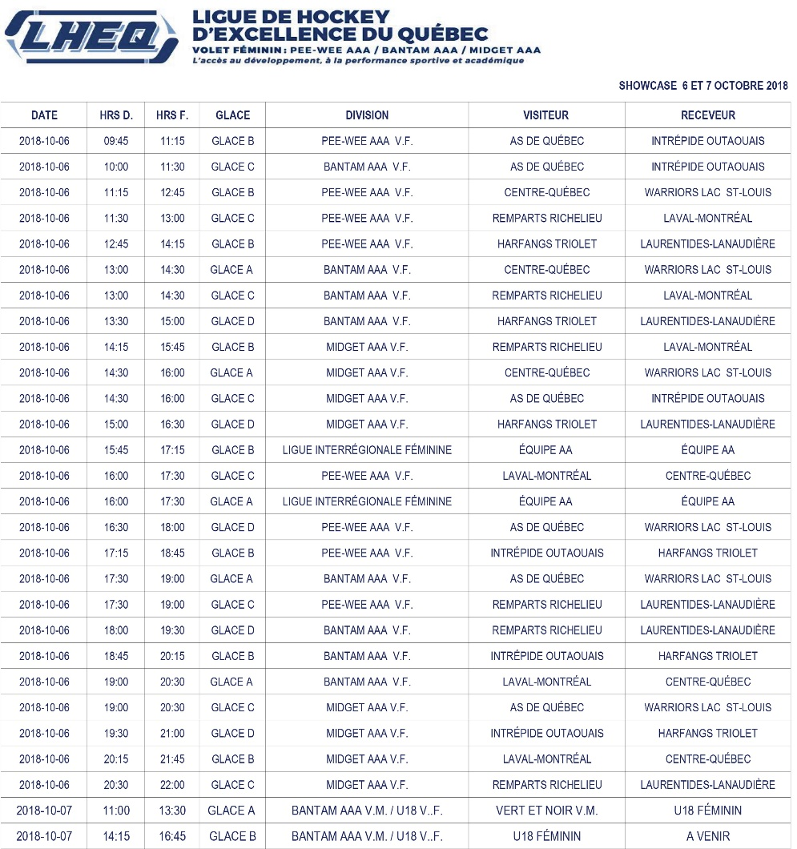
CEGEPs, colleges and universities will be present
Many CEGEPs, colleges and universities are invited to have an information booth on Saturday, October 6th. The goal: to publicize their program in order to encourage the players to pursue their sports and academic career in their school.

College and university recruiters will also watch the players during their matches of the day.

Exhibition games: U18 Team Québec
To complement the Showcase, players from the U18 Team Quebec will jump on the ice, Sunday, October 7th to play exhibition games.

LHEQ – volet féminin – Website now online
The website for the feminine side of the Ligue de hockey d’excellence du Québec is now online. Accessible through the official website (www.lheq.ca), users will now be able to learn about all the news and activities of the LHEQ, both masculine and feminine, in one place.

The Ligue de hockey d’excellence du Québec, feminine league, wishes all its players an excellent 2018-2019 season.

- 30 -

Source
Marie-Joël Desaulniers
Communications and regional support coordinator
Hockey Québec
mjdesaulniers@hockey.qc.ca

[Title: Start of a Tournament]
TOURNAMENT’S LOGO

YOUR LOGO

(City, Province), Date – [Name of the organization, region, MHA] + [meaningful information about the start of the tournament: tournament dates, arenas, length, participating teams, etc.].

“[Quote by the person in charge of the organization, region or MHA]”, acknowledges [Name of the person + title of that person].

[Additional and meaningful information to the announcement]

[Name of the region, MHA, organization, league] wishes a great tournament to all the players.

- 30 -

Source:
[Name of the person in charge]
[Title/Function]
[Name of the organization, region, MHA]
[Contact information - email and/or phone]



The Outaouais region will vibrate to the rhythm of the Dodge Cup

(Montreal, Qc), Wednesday, April 18, 2018 – Until April 22nd, some 3,000 hockey players, as well as their families, will experience the Dodge Cup fever throughout the Outaouais region.

Fiat Chrysler Automobiles, the main sponsor of the Dodge Cup, is on its way to a 31st season. This sponsor is valuable to Hockey Québec because he is deeply involved. The 41st edition of the Provincial ice hockey championships is held under the honorary chairmanship of Mr. Philippe Demers, Honorary President of Fiat Chrysler Automobiles.

“Hockey Québec thanks this faithful partner for its support over the years at the Provincial Championships,” observes Nicolas Minville, president of Hockey Quebec. “This company plays an important social role with consistent and constant commitment. “

Hockey Québec, in collaboration with Hockey Outaouais, presents the masculine’s portion of this 41st edition of its major annual sporting event. The organizing committee of the Outaouais region has selected 15 competition sites to welcome the 213 registered teams.

“We will have a busy edition again this year as more than 412 exciting games will be played across 15 competition venues over a five (5) day period. More than 1,000 volunteers have been and will be on the job to ensure healthy competition on the various rinks in the region to encourage more than 3,000 hockey players, numbers that do not lie about the unparalleled scale that is this day this amateur sports event, “said Hockey Quebec’s General Manager Paul Ménard.

In addition to the trophy awarded to the winner of each category, Hockey Québec also honours the region with the best performance (percentage of points collected in relation to the potential total) on the ice during all the championships with the Raymond Lagacé Trophy.

Dodge players of the game
As part of the 2018 Dodge Cup, Hockey Quebec, through its main partner, Dodge, wants to identify the players of the Dodge match. Dodge will generously offer the player of the game a crystal puck with the Dodge Cup logo.

An official Dodge Cup ring produced by Graduor Sports.
The company Graduor Sports produces the official ring of the Dodge Cup. This high-quality ring is available to all hockey players from the 338 teams participating in both parts of the competition, as well as to all those working with these teams, officials and members of local and regional organizing committees.

Winning teams of the 2018 Dodge Cup will also be able to order a personalized ring, stamped by the team or organization they represent, if they wish. Information about this promotional product will be available at the souvenir kiosk at each of the Dodge Cup venues or by visiting the Graduor Sports website at www.graduor.com.

All the teams that reach the semi-finals or finals of their division are automatically entitled to a medal, while the champion team receives both the banner and the Dodge Cup trophy.

The champion teams identified in the CCM cap
Just like the professional sports championships, every Dodge Cup champion team player will be easily identifiable as he or she walks out of the rink wearing a special CCM signature cap.

The image of the Dodge Cup 2018 appears with the mention Champions. The company CCM Hockey graciously offers this cap to the event’s heroes.

For CCM Hockey, this contribution is an original way of highlighting the intense effort made by the players of the teams participating in the Dodge Cup and highlighting the merits of the champion teams.

Regional championship results online
Fans can follow the action of the championships by consulting the official website of the competition at www.coupe-dodge.qc.ca.

All players and team statistics are regularly updated to allow fans to experience the 2018 Dodge Cup.

Social networks to the forefront
Stay connected to Hockey Québec’s social networks - Facebook, Twitter and Instagram - in addition to the Dodge Cup Twitter throughout the event. Images, results and interesting stories will be on the menu!

For more information on the Dodge Cup and to virtually live the event from April 18 to 22, 2018, visit www.coupe-dodge.qc.ca.

- 30 -

For further information:
Marie-Joël Desaulniers
Communications and regional support coordinator
Hockey Québec
mjdesaulniers@hockey.qc.ca

[Title – Registration period]
YOUR LOGO

(City, Province), Date – [Name of the organization, region, MHA] + [meaningful information about the registration period: dates, length, location, conditions if applicable, etc.].

[Additional and meaningful information to the announcement]

[Name of the region, MHA, organization, league] would like to thank all those who will register and wishes everyone a great [season, tournament, event x] to all our participating players.

- 30 -

Source:
[Name of the person in charge]
[Title/Function]
[Name of the organization, region, MHA]
[Contact information - email and/or phone]

Register your team to the seventh edition of the Super Festival Timbits MAHG

(Montreal, Qc), Wednesday August 2018 – You are a pre-novice player taking part in Hockey Québec’s MAHG program, then register and your team could win one of 12 invites to the 7th edition of the Super Festival Timbits MAHG in Brossard. The event will take place Saturday, May 11, 2019, from 8:00 to 12:00 at the Bell Sports Complex in Brossard.

The selected teams will participate in one hour of ice and several off-ice activities for all the kids. In order to be eligible for the contest, you must be a member of a Pre-Novice team participating in the Hockey Québec MAHG program.

Registration will take place from February 20th to March 20, 2019. Click here to access the form and register.

Hockey Québec thanks everyone who signs up and wishes a great Super Festival Timbits MAHG to all participants.

- 30 -

Source
Hockey Québec
info@hockey.qc.ca

[Title – Generic Announcement]
YOUR LOGO

(City, Province), Date – [Name of the organization, region, MHA] + [meaningful information about the announcement: answer the 5 key questions].

“[Quote by the person in charge of the organization, region or MHA issuing the announcement]”, acknowledges [Name of the person].

[Additional and meaningful information to the announcement]

[Name of the region, MHA, organization, league] would like to thank [mention the target audience + information about the announcement].

- 30 -

Source:
[Name of the person in charge]
[Title/Function]
[Name of the organization, region, MHA]
[Contact information - email and/or phone]

Hockey Québec will hold a specialized clinic for goaltenders

(Montreal, Qc), Tuesday, October 9, 2018 – Hockey Québec will hold a specialized clinic for goaltenders, this Sunday, October 28, 2018, at the Bell Centre in Montreal. The development activity will be offered free of charge to all those who register before Friday, October 19th.

“As a Federation, we want to provide the best coaching to our Quebec players and coaches. Bringing together many goaltenders from across the province under one roof will certainly generate a good exchange and sharing of knowledge for all, “says the technical director of Hockey Quebec, Yves Archambault.

Hockey Québec offers various specialized clinics to its members: Puck Control, Skating, Developing Defencemen to name only those. You will find more on this subject online here.

Hockey Québec wishes an excellent clinic to all the participating goaltenders.

- 30 -

Source
Yves Archambault
Technical Director
Hockey Québec
yarchambault@hockey.qc.ca

[Title – Nomination]
YOUR LOGO

(City, Province), Date – [Name of the organization, region, MHA] + [meaningful information about the nomination: Name of the person, their title, who the replacement is for, etc.].

“[Quote for the hired person, newly in this role]” says [Name of the person and title].

[Information about the professional background or experiences within the organization and contact information to contact the person]

“[Quote from the person hiring or making the announcement]”, says [Name and title of the quoted person].

[Entry into office is immediate \ Entry into function is effective as from DATE].

[Name of the region, MHA, organization, league] congratulates [Name of the nominated person] for their position [name of the position] and wish [him/her] well in [his/her] new responsibilities.

- 30 -

Source:
[Name of the person in charge]
[Title/Function]
[Name of the organization, region, MHA]
[Contact information - email and/or phone]

Jean-Simon Marchand appointed reporter for the LHEQ

Montreal (QC), Friday, October 19, 2018 – It is with great pleasure that the Ligue de hockey d’excellence du Québec (LHEQ) announces the appointment of Jean-Simon Marchand as a reporter for the LHEQ.

“It is with a sense of pride and interest that I am joining the LHEQ today. This new challenge fits exactly with the goals of my professional development and I can’t wait to get started,” says newly appointed Jean-Simon Marchand.

In the process of obtaining his college diploma in Arts et technologie des médias from Cégep de Jonquière, Jean-Simon Marchand is passionate about sports. Since high school, he has shown a desire to get involved with student sports teams, starting with the Harfangs du Triolet. Then, he used his expertise sporadically for the Jonquière Élites, his adopted city during his college studies, in the Ligue de hockey de développement midget AAA du Québec. A former hockey player, Mr. Marchand is also an official (referee and linesman) for his home region, Hockey Sherbrooke.

“His knowledge of the environment, his experience in the LHEQ and his desire to learn and contribute to the success of the LHEQ make him the ideal candidate to occupy this position,” said Paul Ménard, General Director of Hockey Québec.

Jean-Simon Marchand’s main tasks will be to conduct interviews with the various LHEQ participants, write the stories and publish them on the league’s platforms. He will also manage the LHEQ social network accounts. You can reach Mr. Marchand by email at journalisteLHEQ@hockey.qc.ca.

His entry into function is immediate.

Please join the entire LHEQ team to congratulate and welcome Jean-Simon Marchand to the LHEQ team as a journalist.

Source
Marie-Joël Desaulniers
Communications and regional support coordinator
Hockey Québec
mjdesaulniers@hockey.qc.ca

[Title – President’s Message]
YOUR LOGO

[Name of the organization, region, MHA] + [primary information you want to share about the launch of tournaments, season, encouragement, etc.].

[Additional information to the president’s message]

[Name of the region, MHA, organization, league] wishes [wishes related to your president’s message] to all our participating players.

Electronic signature

[Your name]
[Function: President of [name of the region, MHA, organization]]
[Contact information]

Let’s be proud of what we are achieving

It is with renewed pleasure that Hockey Québec, its Board of Directors and the members of the Executive Committee of the Ligue de Hockey d’Excellence du Québec (LHEQ) wish an excellent season to the teams and the organization of Pointe Corsairs -Levy.

The deployment of a season cannot be done without the generous involvement of many volunteers. It is a precious wealth for a society and for its well-being. The quality of our organizations is synonymous with the vitality of hockey in Quebec. Let’s be proud of what we achieve, be proud of the work done by our coaches and the efforts made by players for their development, in both academics and sports.

We wish you a great hockey season 2018-2019! May it be done under the sign of development and sportsmanship!



Yves Sigouin
Hockey Québec President
ysigouin@hockey.qc.ca

[Facebook Post]

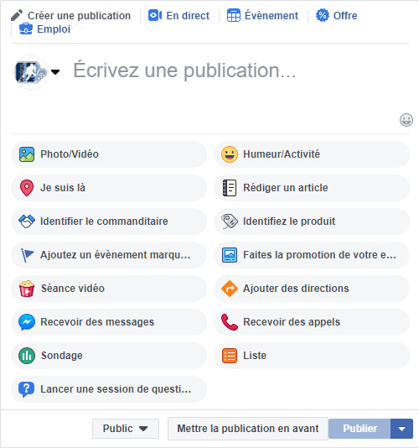

Example #1 – Facebook Post
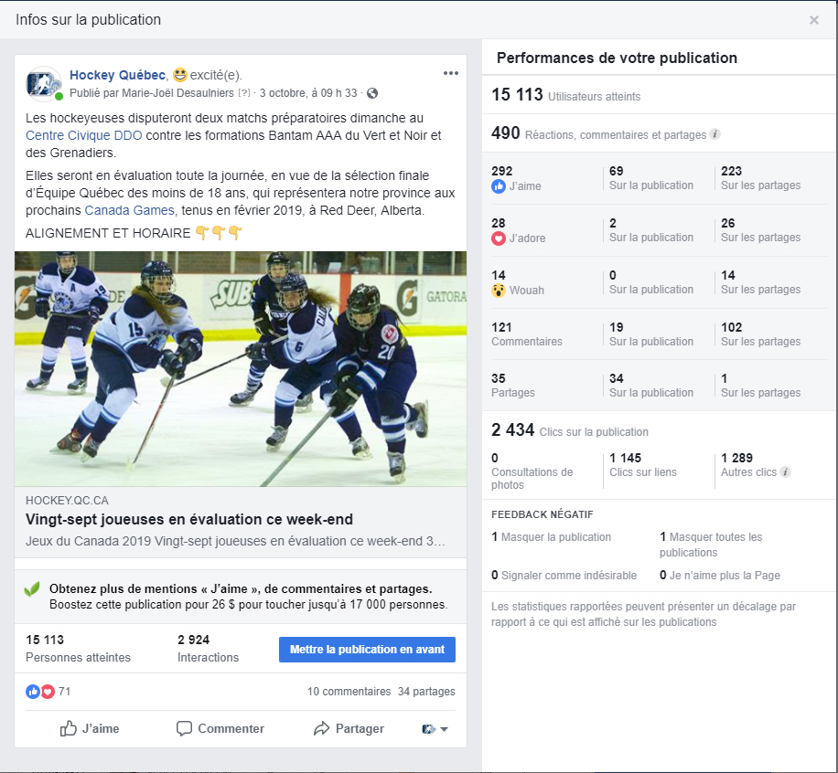

Example #2 – Facebook Post

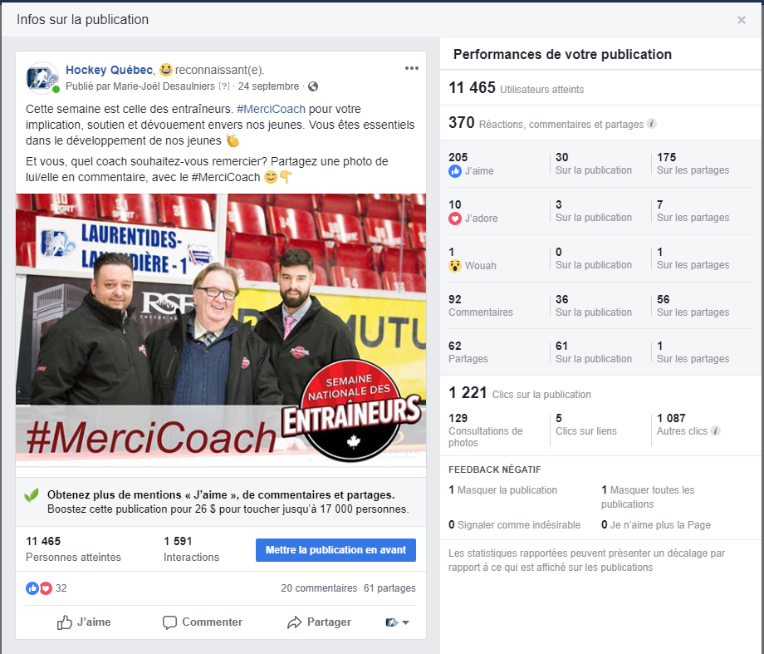

Example #3 – Sharing a Facebook Post

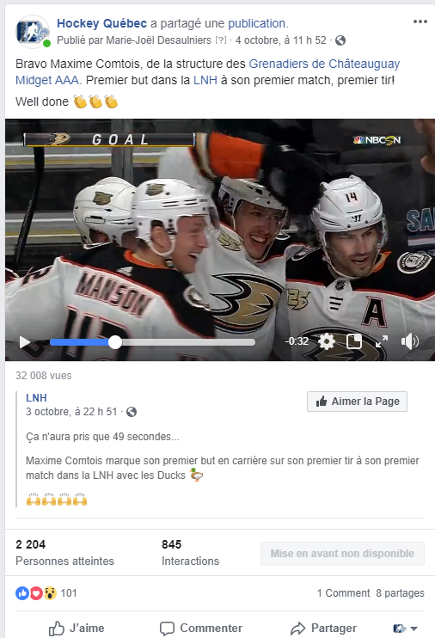

[Twitter Post]

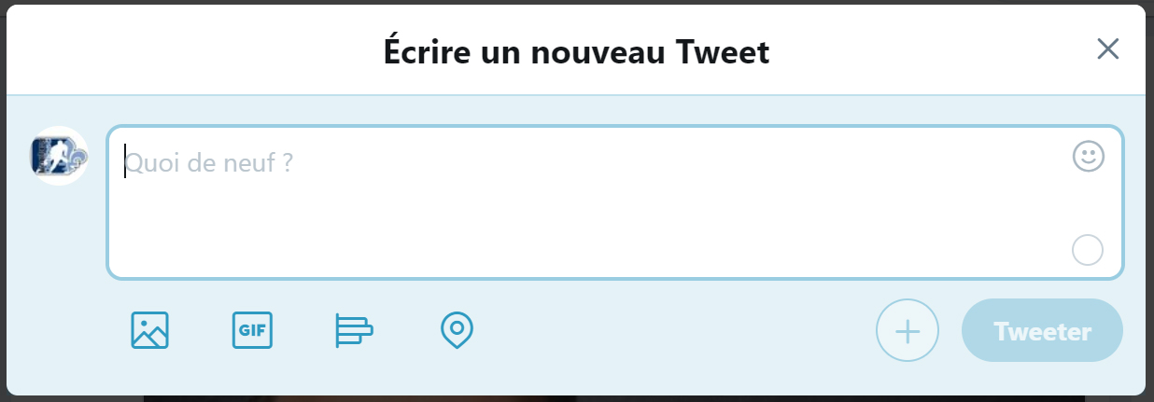

About Twitter
There isn’t a perfect number of tweets in a day or a good time to tweet. Instead, focus on creating relevant content for your target audience that reflects your business, and publish at a steady pace.

Avoid scheduled publications whether from Spordle, your website or Facebook. Each platform has its own goal. Better take the time to create and write different publications for each of them.

Example #1 Twitter

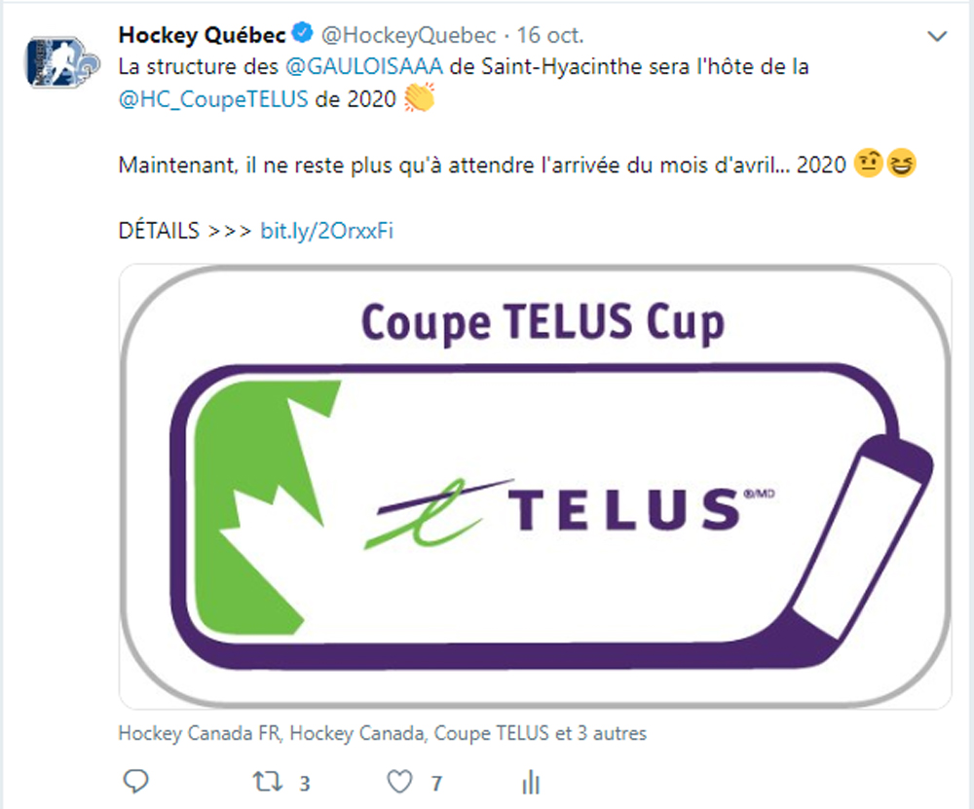

Link: https://twitter.com/HockeyQuebec/status/1052298779326640128

Example #2 Twitter

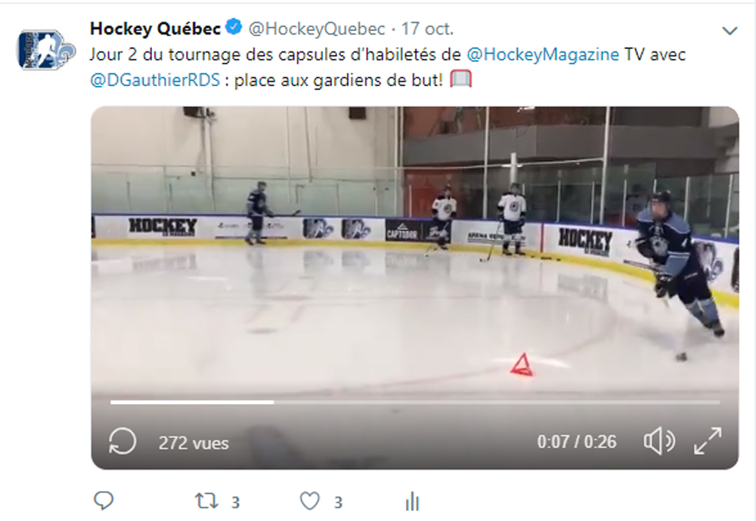

Link : https://twitter.com/HockeyQuebec/status/1052544042129600512

Example #3 Twitter

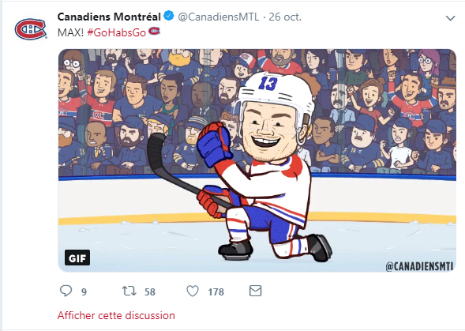

Link : https://twitter.com/CanadiensMTL/status/1055628477892907008

[Instagram Post]

Step #1 - Select one or more pictures you want to post

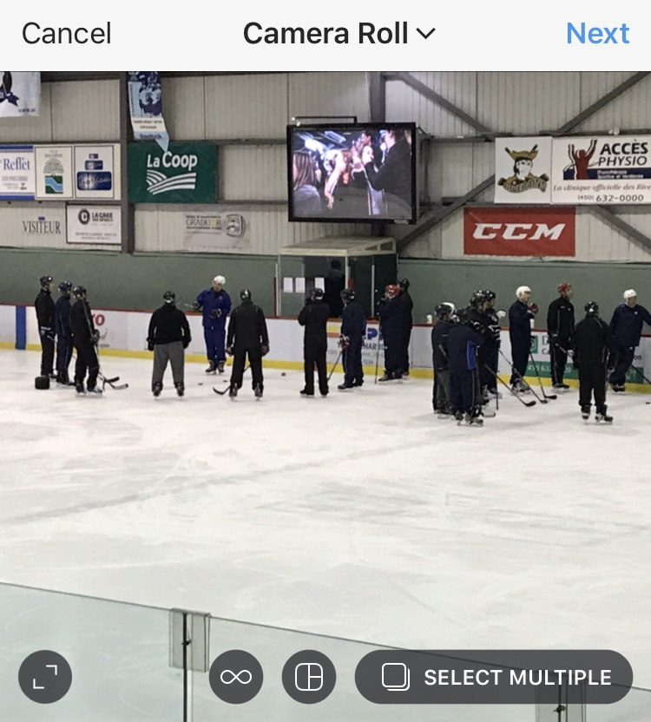

Step # 2 - Choose a filter, is desired, to apply to your picture or pictures.

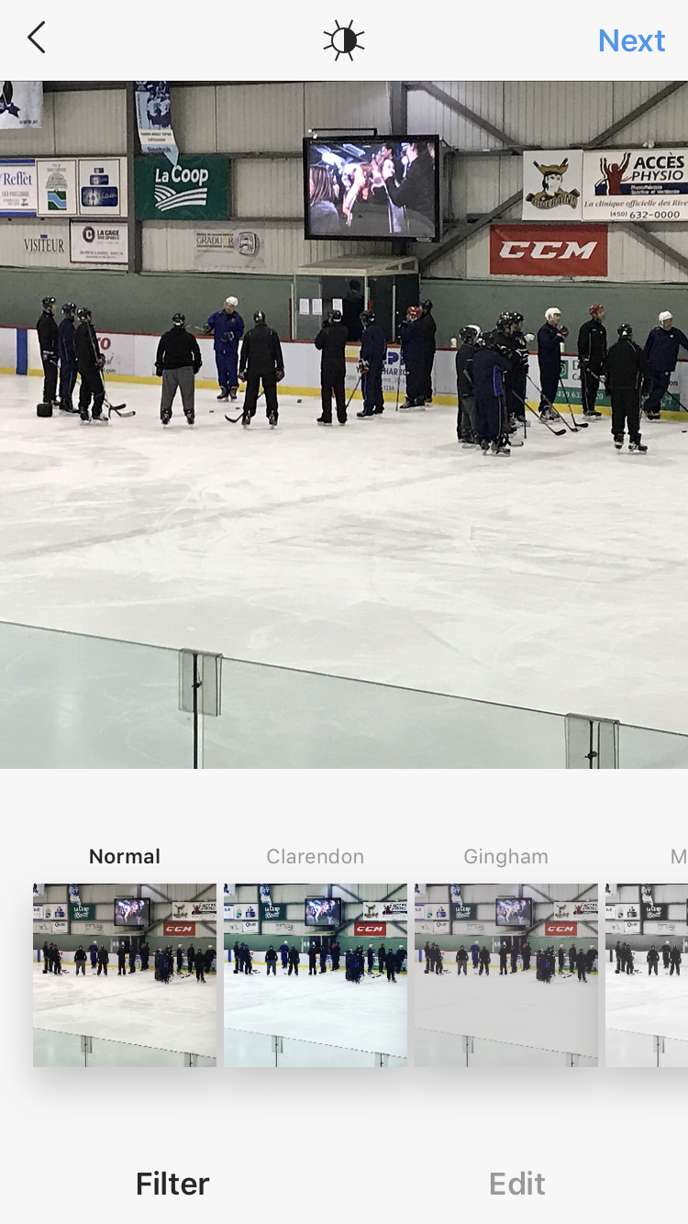

Step #3 – Post the selected picture or pictures

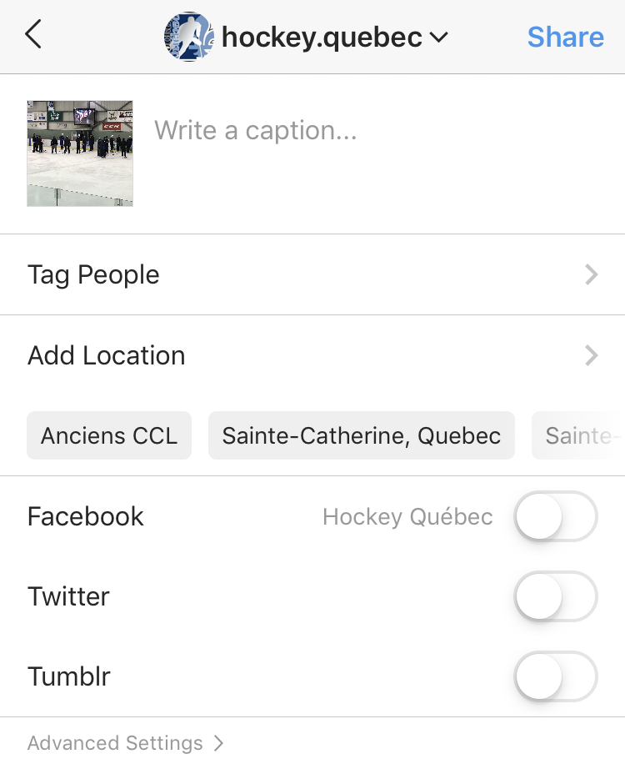

Instagram Example

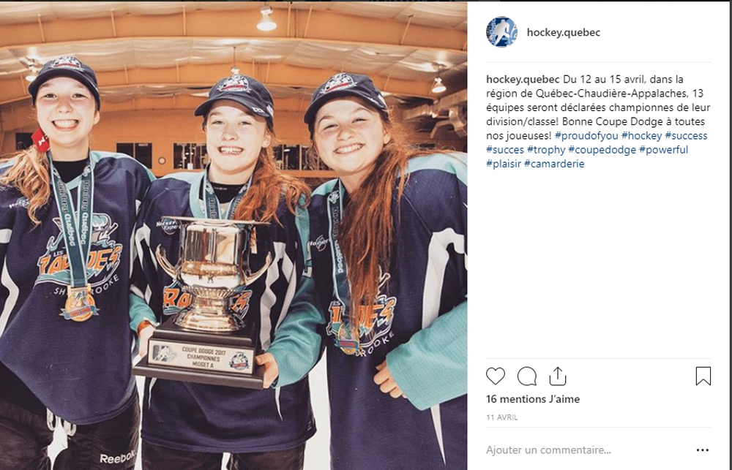

Snapchat Post

Step #1 - Take a picture or video

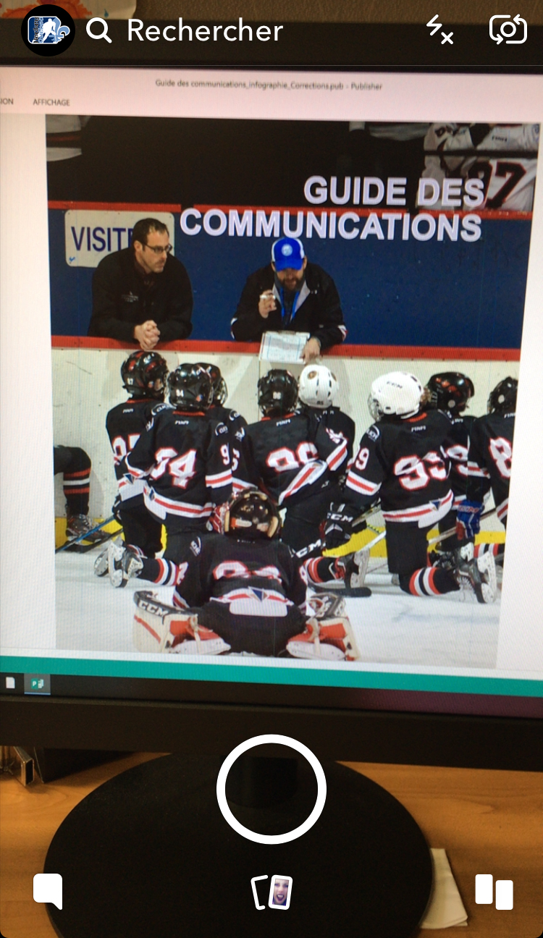

Step #2 – Send your picture or video

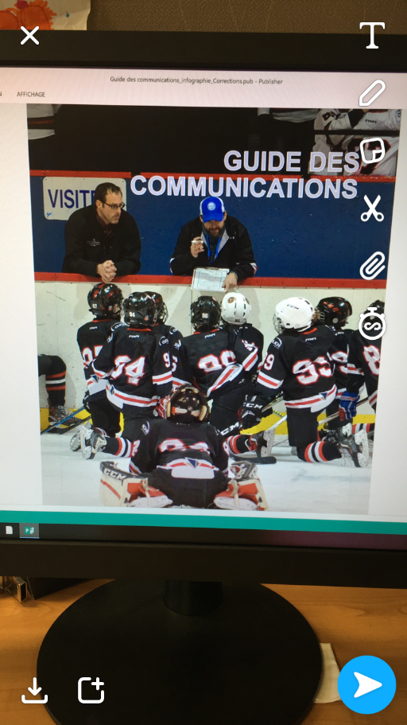

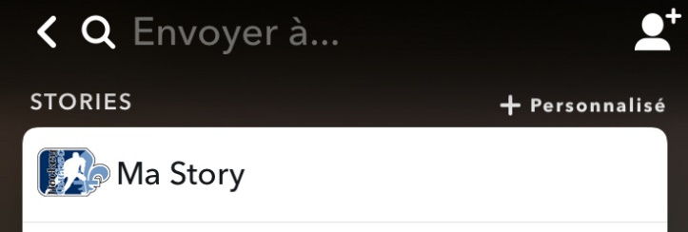

About Snapchat
Snapchat is a free photo and video sharing app available on iOS and Android mobile platforms. The difference with this application is the existence of a time limit for viewing the media sent to its recipients. Each picture or video sent can only be visible to the recipient for a period of time ranging from one to ten seconds, but also, since recently, without time limits.

The app also allows users to create a Story. It is a juxtaposition of several photos/videos. A story can be seen as many times as the user wants, but each story element has a life of 24 hours. Most users are between 13 and 34 years old.

